Customer Segmentation Analysis using RFM Analysis and K-Means Clustering
Submitted By
Name: Bhakti Baghel
Introduction
Abstract
Customer segmentation is one of the most important techniques used by businesses to understand customer behavior. By grouping customers based on their purchasing habits, companies can create personalized marketing strategies, improve customer satisfaction, and increase profits.
This project uses the Sample Superstore dataset to perform customer segmentation through RFM (Recency, Frequency, Monetary) Analysis and K-Means Clustering. The analysis identifies different customer groups and provides recommendations to improve customer retention and business growth.

Objectives
The objectives of this project are:
- To analyze customer purchasing behavior.
- To calculate Recency, Frequency, and Monetary (RFM) values.
- To perform customer segmentation using K-Means Clustering.
- To visualize customer groups.
- To provide marketing strategies for each customer segment.

Dataset Description
The project uses the Sample Superstore dataset, which contains sales records from a retail company.
Important Features
- Order ID
- Order Date
- Customer ID
- Customer Name
- Sales
- Profit
- Category
- Region

Methodology
- Tools Used
- Python
- VS Code
- Pandas
- NumPy
- Matplotlib
- Seaborn
- Scikit-learn

Data Preprocessing
The following preprocessing steps were performed before analysis:
- Imported the dataset.
- Checked for missing values.
- Converted Order Date into DateTime format.
- Created a snapshot date for Recency calculation.
- Grouped data by Customer ID.
- Calculated RFM values.
- Standardized the dataset for clustering.

RFM Analysis
RFM Analysis evaluates customers using three metrics:
Recency (R)
Number of days since the customer's last purchase.
Frequency (F)
Total number of purchases made by a customer.
Monetary (M)
Total amount spent by a customer.

These metrics help identify high-value customers and those at risk of leaving.

K-Means Clustering
Standardization
Before applying K-Means, the RFM values were standardized using StandardScaler to ensure equal importance for all variables.
Elbow Method
The Elbow Method was used to determine the optimal number of clusters by plotting the Within-Cluster Sum of Squares (WCSS) against the number of clusters.

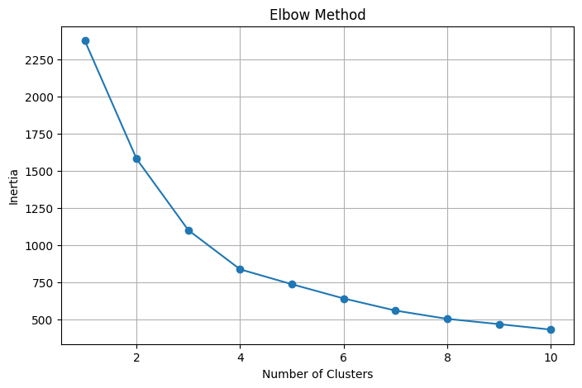
K-Means Clustering
K-Means clustering divided customers into four distinct groups based on their purchasing behavior.
The clustering algorithm grouped customers with similar RFM values together, making customer analysis easier.

Cluster Summary
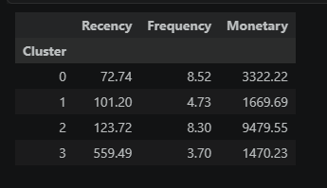

Results and Visualizations
Customer Segmentation Scatter Plot
The scatter plot illustrates the relationship between customer Recency and Frequency while highlighting the clusters identified by the K-Means algorithm.
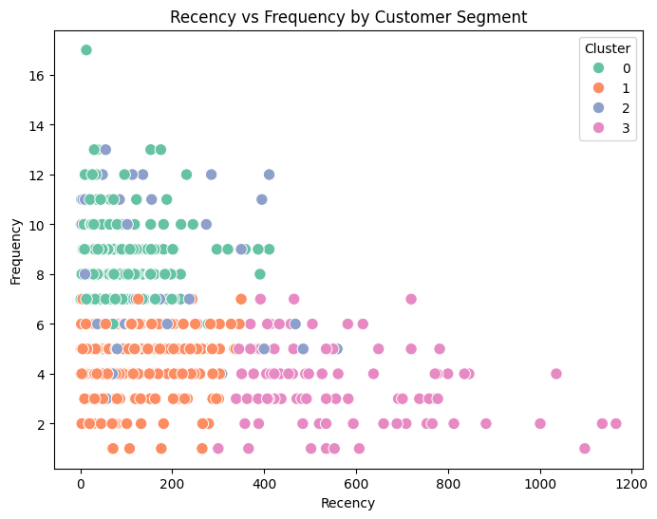
Customer Distribution by Cluster
The distribution chart shows the number of customers in each cluster.
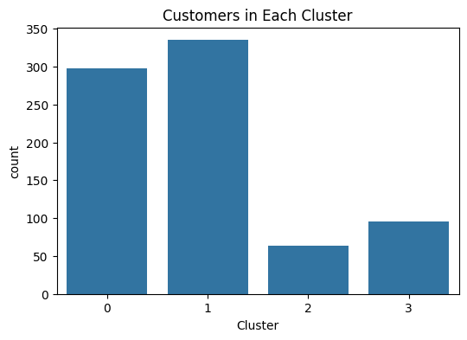

Average Monetary Value
The bar chart compares the average spending of customers across different clusters.
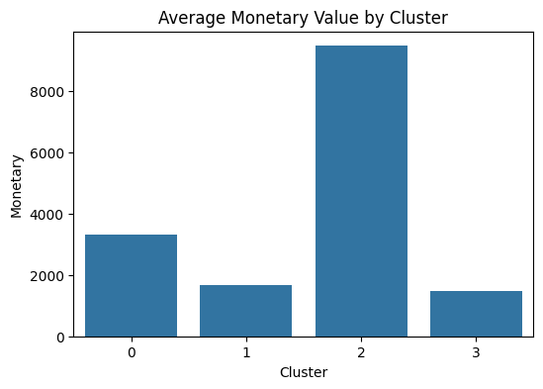
Key Observations
Customers were successfully grouped into four clusters.
Some customers purchase frequently and contribute significantly to revenue.
A group of customers has low purchase frequency and requires marketing attention.
Customer spending varies considerably among different segments.

Business Insights and Recommendations
Customer Segments
Champions
Characteristics:
- High purchase frequency
- High spending
- Recent purchases
Recommendation:
- Offer VIP memberships.
- Provide exclusive discounts.
- Introduce premium loyalty programs.

Loyal Customers
Characteristics:
- Frequent purchases
- Consistent spending
Recommendation:
- Personalized product recommendations.
- Loyalty reward programs.
- Early access to new products.
Potential Customers
Characteristics:
- Moderate purchase frequency
- Average spending
Recommendation:
- Promotional offers.
- Cross-selling and upselling strategies.
- Email marketing campaigns.
At-Risk Customers
Characteristics:
- Long time since last purchase
- Low purchase frequency
Recommendation:
- Win-back campaigns.
- Special discounts.
- Personalized reminder emails.

Conclusion and Future Scope
Conclusion
This project successfully implemented customer segmentation using RFM Analysis and K-Means Clustering.

The segmentation process helped identify different customer groups based on purchasing behavior. The insights generated from the analysis can support targeted marketing strategies, improve customer retention, and increase business profitability.

Overall, the project demonstrates how machine learning techniques can assist businesses in making data-driven decisions.

Future Scope
Future improvements can include:
- Integrating demographic information into the analysis.
- Applying advanced clustering algorithms such as DBSCAN or Hierarchical Clustering.
- Predicting customer churn using machine learning models.
- Developing an interactive Tableau or Power BI dashboard for real-time customer monitoring.
References
- Scikit-learn Documentation
- Pandas Documentation
- Matplotlib Documentation
- Seaborn Documentation
- Sample Superstore Dataset

